INTRODUCTION

- INTRODUCTION
1.1 INTRODUCTION:
Phishing is a new word produced from 'fishing', it refers to the act that the attacker allure users to visit a faked Web site by sending them faked e-mails (or instant messages), and stealthily get victim's personal information such as user name, password, and national security ID, etc. This information then can be used for future target advertisements or even identity theft attacks (e.g., transfer money from victims' bank account). The frequently used attack method is to send e-mails to potential victims, which seemed to be sent by banks, online organizations, or ISPs. In these e-mails, they will make up some causes, e.g. the password of your credit card had been mis-entered for many times, or they are providing upgrading services, to allure you visit their Web site to conform or modify your account number and password through the hyperlink provided in the e-mail. If you input the account number and password, the attackers then successfully collect the information at the server side, and is able to perform their next step actions with that information (e.g., withdraw money out from your account).Phishing itself is not a new concept, but it's increasingly used by phishers to steal user information and perform business crime in recent years. Within one to two years, the number of phishing attacks increased dramatically.
The common characteristics of the hyperlinks in phishing e-mails. Our analysis identifies that the phishing hyperlinks share one or more characteristics as listed below:
1) The visual link and the actual link are not the same;
2) The attackers often use dotted decimal IP address instead of DNS name;
3) Special tricks are used to encode the hyperlinks maliciously;
4) The attackers often use fake DNS names that are similar (but not identical) with the target website.

1.2 PURPOSE
An end-host based anti-phishing algorithm which we call Link Guard, based on the characteristics of the phishing hyperlink. Since Link Guard is character-based, it can detect and prevent not only known phishing attacks but also unknown ones. We have implemented Link Guard in Windows XP, and our experiments indicate that Link Guard is light-weighted in that it consumes very little memory and CPU circles, and most importantly, it is very effective in detecting phishing attacks with minimal false negatives. Link Guard detects 195 attacks out of the 203 phishing archives provided by APWG without knowing any signatures of the attacks.
1.3 EXISTING SYSTEM
1) Detect and block the phishing Web sites in time: If we can detect the phishing Web sites in time, we then can block the sites and prevent phishing attacks. It's relatively easy to (manually) determine whether a site is a phishing site or not, but it's difficult to find those phishing sites out in time. Here we list two methods for phishing site detection.
A) The Web master of a legal Web site periodically scans the root DNS for suspicious sites (e.g.www.1cbc.com.cnvs.www.icbc.com.cn).
B) Since the phisher must duplicate the content of the target site, he must use tools to (automatically) download the Web pages from the target site.
It is therefore possible to detect this kind of download at the Web server and trace back to the phisher. Both approaches have shortcomings. For DNS scanning, it increases the overhead of the DNS systems and may cause problem for normal DNS queries, and furthermore, many phishing attacks simply do not require a DNS name. For phishing download detection, clever phishers may easily write tools which can mimic the behavior of human beings to defeat the detection.
2) Enhance the security of the web sites: The business Websites such as the Web sites of banks can take new methods to guarantee the security of users' personal information. One method to enhance the security is to use hardware devices. For example, the Barclays bank provides a hand-held card reader to the users. Before shopping in the net, users need to insert their credit card into the card reader, and input their (personal identification number) PIN code, then the card reader will produce a onetime security password, users can perform transactions only after the right password is input. Another method is to use the biometrics characteristic (e.g. voice, fingerprint, iris, etc.) for user authentication. For example, PayPal had tried to replace the single password verification by voice recognition to enhance the security of the Web site.
3) Block the phishing e-mails by various spam filters: Phishers generally use e-mails as 'bait' to allure potential victims. SMTP (Simple Mail Transfer Protocol) is the protocol to deliver e-mails in the Internet. It is a very simple protocol which lacks necessary authentication mechanisms. Information related to sender, such as the name and email address of the sender, route of the message, etc., can be counterfeited in SMTP. Thus, the attackers can send out large amounts of spoofed e-mails which are seemed from legitimate organizations. The phishers hide their identities when sending the spoofed e-mails, therefore, if anti-spam systems can determine whether an e-mail is sent by the announced sender (Am I Whom I Say I Am?), the phishing attacks will be decreased dramatically.
4) Install online anti-phishing software in user’s computers: Despite all the above efforts, it is still possible for the users to visit the spoofed Web sites. As a last defense, users can install anti-phishing tools in their computers.
The Anti-phishing tools in use today can be divided into two categories:
- Blacklist/white list based
- Rule-based
Category I: When a user visits a Web site, the anti-phishing tool searches the address of that site in a blacklist stored in the database. If the visited site is on the list, the anti-phishing tool then warns the users. Tools in this category include Scam Blocker from the EarthLink Company, Phish Guard, and Net craft, etc. Though the developers of these tools all announced that they can update the blacklist in time, they cannot prevent the attacks from the newly emerged (unknown) phishing sites.
Category II: this category of tools uses certain rules in their software, and checks the security of a Web site according to these rules. Examples of this type of tools include Spoof Guard developed by Stanford, Trust Watch of the Geo Trust, etc. Spoof Guard checks the domain name, URL (includes the port number) of Web site, it also checks whether the browser is directed to the current URL via the links in the contents of e-mails. If it finds that the domain name of the visited Web site is similar to a well-known domain name, or if they are not using the standard port, Spoof Guard will warn the users. In Trust Watch, the security of a Web site is determined by whether it has been reviewed by an independent trusted third party organization. Both Spoof Guard and Trust Watch provide a toolbar in the browsers to notify their users whether the Web site is verified and trusted. It is easy to observe that all the above defense methods are useful and complementary to each other, but none of them are perfect at the current stage.
1.4 PROPOSED SYSTEM
I) Classification of the hyperlinks in the phishing e-mails
In order to (illegally) collect useful information from potential victims, phishers generally tries to convince the users to click the hyperlink embedded in the phishing e-mail. A hyperlink has a structure as follows.
<a href="URI "> Anchor text <\a>
where ‘URI' (universal resource identifiers) provides the necessary information needed for the user to access the networked resource and 'Anchor text' is the text that will be displayed in user's Web browser.
Examples of URIs are:
- http://www.google.com
- https://www.icbc.com.cn/login.html
- ftp://61.112.1.90:2345.
'Anchor text' in general is used to display information related to the URI to help the user to better understand the resources provided by the hyperlink. In the following hyperlink, the URI links to the phishing archives provided by the APWG group, and its anchor text "Phishing Archive" informs the user what's the hyperlink is about. <a href http://www.antiphishing.org/phishing-archive.html">Phishing Archive </a>
Note that the content of the URI will not be displayed in user's Web browser. Phishers therefore can utilize this fact to play trick in their 'bait' e-mails. In the rest of the paper, we call the URI in the hyperlink the actual link and the anchor text the visual link. After analyzing the 203 (there are altogether 210 phishing e-mails, with 7 of them with incomplete information or with malware attachment and do not have hyperlinks).Phishing email archives from Sep. 21st 2003 to July 4th 2005 provided by APWG.

REQUIREMENTS

2. REQUIREMENTS
2.1Functional Requirements:
Functional requirements are associated with specific functions, tasks or behaviours the system must support. The functional requirements address the quality characteristic of functionality while the other quality characteristics are concerned with various kinds of non-functional requirements. Because non-functional requirements tend to be stated in terms of constraints on the results of tasks which are given as functional requirements (e.g., constraints on the speed or efficiency of a given task), a task-based functional requirements statement is a useful skeleton upon which to construct a complete requirements statement. That is the approach taken in this work. It can be helpful to think of non-functional requirements as adverbially related to tasks or functional requirements:
There are three modules involved in this project:
  - Creation of a mail system and database operations
  - Composes, send and receive a mail
  - Implementation of the Link Guard algorithm
2.2Non-Functional Requirements
Non-functional requirements are requirements that specify criteria that can be used to judge the operation of a system, rather than specific behaviors. This should be contrasted with functional requirements that specify specific behavior or functions. In general, functional requirements define what a system is supposed to do whereas non-functional requirements define how a system is supposed to be. Non-functional requirements are often called qualities of a system. Other terms for non-functional requirements are "constraints", "quality attributes", "quality goals" and "quality of service requirements". Qualities, aka. Non-functional requirements, can be divided into two main categories.
- Execution qualities, such as security and usability, are observable at run time.
- Evolution qualities, such as testability, maintainability, extensibility and scalability, are embodied in the static structure of the software system.

Scalability:
The network-deployment cost for scaling up these systems must be manageable merely having the technology to provide a user service is not sufficient. The service-provider involvement requires that different infrastructure services be available. This information helps service providers to determine where to invest next. The data-collection facility is that service want to integrate into their service and system.
Interoperability:
It is important that the interface is simple and intuitive Instead of making products and services ever more sophisticated, they must be made intuitive, simple, and useful in solving problems.
Reliability:
In order to be more reliable JainSIP is used. It enhances the performance as well as the reliability of the system and communicate with more number of people at a time. It is imperative that the service reaches thousands of people, and that it is absolutely reliable.
Portability:
In order to be more portable we use Application server Tomcat5.0 and even the voice server is independent of the platform.
Extensibility:
The application should be widely extensible, where we can include many services like fax can be added in to UMS server. Also many call routing mechanism can be included.
Efficiency:
The system should function in an efficient manner with proper acknowledgements and responses at high speed.

2.3 System Requirements Specifications
Software Requirements

The minimum requirements for detection and prevention of phishing attacks are:
- Operating System : Windows 2000/XP
- Documentation Tool : Ms word 2000

Hardware Requirements
The minimum hardware requirements are:
- Hard disk : 20 GB and above
- RAM : 256 MB and above
- Processor speed : 1.6 GHz and above

OVERVIEW OF CONCEPTS

3. OVERVIEW OF CONCEPTS
3.1 JAVA
Now-a-days all are familiar with Internet, the worldwide network of computers, which connects together thousands of computer all over the world. These network connections are increasing day by day in a rapid rate, so the network traffic is increasing at a pulse rate. Computers connected to the net are from many different manufacturers, running on different operating systems and they differ in architecture, computing power and capacity. By considering this point SUN Microsystems Corporation felt the need for a new programming language suitable for this heterogeneous Environment and java was the solution. This breaks barriers between different computers, chips and operating systems. Using java your application become compatible with all operating systems.
FEATURES OF JAVA:
- Simple
- Secure
- Portable
- Object oriented
- Robust
- Multithreaded
SIMPLE: It is simple for professional programmer to learn & they can use it effectively. If we already know object oriented programming, then learning java is very easy. It inherits syntax from c & object oriented features from c++, so if the user knows c\c++ then it will be a easy way to do effective java programming.
SECURE: As we know many people are effected by viral infection when they download an executable file or program. Rather than, virus programs we have malicious programs that can gather private information, such as credit card number, bank account balances & passwords by searching the contents of your computers local file system. Java has a better answer for this effect i.e., “FIREWALL” between networked application and your computer.

PORTABLE: As already we have discussed about compatibility of operating system, computers, chips. In Internet the programs have to be dynamically downloaded to all the various types of platforms. For this purpose java program will generate a byte code (which is not a executable code). Byte code is a highly optimized set of instructions designed to be executed by java run system, which is called as JVM (Java Virtual Machine).
OBJECT ORIENTED: Java is purely object oriented. The object model in java is simple and easy to extend, while simple types, such as integers, are kept as high-performance non-objects.
ROBUST: The ability to create robust programs was given a high priority in the design of java. To gain reliability, java restricts you in a few key areas, to force you to find your mistakes early in program development. At the same time, java frees you from having to worry about many of the most common causes of programming errors. Because java is a strictly typed language, it checks your code at Compile time. Java is robust for two reasons; they are Memory management & mishandled exceptional task in traditional programming environments.
3.2 JAVA DATABASE CONNECTIVITY:
JDBC is a Java API for executing SQL statements. (JDBC is often thought of as “Java Database Connectivity”) .It consists of a set of classes and interfaces written in the java programming language.
Using JDBC, it is easy to send SQL statements to virtually any relational database. In the other words, with the JDBC API, it is not necessary to write to one program to access a Sybase database, another program to access Informix database, another program to access Oracle database, and so on. One can write a single program using the JDBC API, and the program will be able to send SQL statements to the appropriate database. The combinations of JAVA and JDBC let’s a programmer writes it once and run it anywhere.
Java, being robust, secure, easy to use, easy to understand, and automatically downloadable on a network, is an excellent language basis for database applications.

JDBC extends what can be done in Java. For example, with Java and the JDBC API, it is possible to publish a web page, which contains an applet that uses information obtained from a remote database. With more and more Programmers using the Java Programming language, the need for easy database access from java is continuing to grow.
MIS managers like the combination of Java and JDBC because it makes disseminating information easy and economical, Businesses can continue to use their installed database and access information even if it is stored on different database management systems. Development time for new application is short. A programmer can write an application or an update once, put it on the server, and everybody has access to the latest version. A Low Level API and a Base for Higher-level APIs.
JDBC is a “Low level “ interface that means that it is used to invoke SQL commands directly, it works very well in this capacity and is easier to use than other database connectivity APIs, but it was designed to be a base upon which to build higher level interfaces and tools. A high level interface is “user-friendly”, using a more understandable or more convenient API that is translated behind the scenes into a low level interface such as JDBC. At the time of writing, two kinds of higher level APIs are under development of top of JDBC.
1) An embedded SQL for Java. At least one vendor plan to build this DBMS implement SQL, a language designed specifically for use with databases. JDBC requires that the SQL statements be passed as Strings to Java methods. The embedded SQL preprocessor then translates this JAVA/SQL mix into Java with JDBC calls.
2) A direct mapping of relational database tables to Java classes. In this “object/relational” mapping, each row of the table becomes an instance of that class, and each column value corresponds to an attribute of that instance. Programmers can then operate.
ODBC is hard to learn. It mixes simple and advanced features together, and it has complex options even for simple queries. JDBC, on the other hand, was designed to keep simple things simple while allowing more advanced capabilities where required.

A Java API like JDBC is needed in order to enable a “Pure Java” solution. When ODBC is used, the ODBC Driver Manager and drivers must be manually installed on every client machine. When the JDBC driver is written completely in Java, however, JDBC code is automatically installable, portable, and secure on all platforms from network computers to mainframes.
3.3 Database Management System (DBMS):
A Database is an integrated collection of user related data stored with minimum redundancy, serves many users/applications quickly and efficiently.A database system is basically a computerized record keeping system, i.e. it is a computerized system whose overall purpose is to maintain information and make that information available on demand.
DBMS is a collection of inter-related data and set of programs that allow several users to access and manipulate data. Its main purpose is to provide users with an abstract view of the data, i.e. the system hides certain details of how the data is stored and maintained.
Database Management System is divided into 4 main components
- Database
- Hardware
- Software
- User
Database: It consists of collection of persistent data that is used by the application system.
Hardware: The processor(s) and associated main memory that are used to support the execution of database system software..
Software: The layer between the physical database and the users that handles all requests from the user for access to the database.
User: There are three types of users
- Application Programmers
- End User
- Database Administrator (DBA)
3.3.1 TYPES OF DBMS
There are four major categories of DBMS data models.
- Hierarchical
- Network
- Inverted
- Relational
3.3.2 RELATIONAL DATABASE MANAGEMENT SYSTEMS
Database Management System has evolved from hierarchical to network to relational models. Today, the most widely accepted database model is the relational model. The relational database management system uses only its relational capabilities to manage the information stored in the database. The relational model has three different aspects.
- Structures
- Operation
- Integrity rules
Structures:
They are well-defined objects that store the data of a database structure and the data contained within them can be manipulated by operations.
Operations:
They are clearly defined actions that allow users to manipulate the data and structures of a database. The operations on a database must adhere to a predefined set of integrity rules.
3.4 JAVA SERVER PAGE (JSP):
Java Server Pages™ (JSP) is a new technology for web application development that has received a great deal of attention since it was first announced.

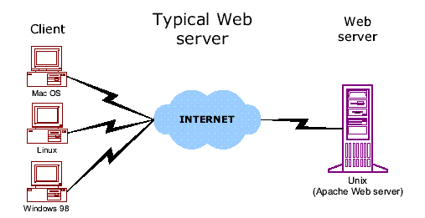
A JSP is similar in design and functionality to java servlet. It is called by the client to provide a web service, the nature of which depends on the J2EE application. However, a JSP differs from a servlet in the way in which the JSP is written. Java Servlet is written using Java programming language and responses are encoded as an output string object that is passed to the println() method. In contrast a JSP is written in HTML, XML, or in the client’s format that is interspersed with scripting elements, directives, and actions comprised of Java Programming language and JSP syntax.
There are three methods that are automatically called when the JSP is requested and the JSP terminates normally. These are the jspInt () method, the jspDestroy () method, and the service() method.
The jspInt () method is called first when the jsp is requested and is used to initialize objects and variables that are used throughout the life of the JSP. The jspDestroy() method is automatically called when the JSP terminates normally. It isn’t called when the JSP abruptly terminates. The service () method is automatically called and retrieves connection to HTTP.
The jsp programs are executed by a JSP virtual machine that runs on a web server. Therefore you will need to have access to a JSP virtual machine to run your JSP program. One of the most popular JSP virtual machines is TOMCAT

1. JSP is Java-based, and Java is well-suited for enterprise computing.
In fact, JSP is a key part of the Java 2 Enterprise Edition (J2EE) platform and can take advantage of the many Java Enterprise libraries, such as JDBC, JNDI, and Enterprise Java Beans.
2. JSP supports a powerful model for developing web applications that separates presentation from processing..
In the early days of the Web, the only tool for developing dynamic web content was the Common Gateway Interface (CGI). CGI outlined how a web server made user input available to a program, as well as how the program provided the web server with dynamically generated content to send back. CGI scripts were typically written in Perl. (In fact, CGI Perl scripts still drive numerous dynamic web sites.) However, CGI is not an efficient solution. For every request, the web server has to create a new operating-system process, load a Perl interpreter and the Perl script, execute the script, and then dispose of the entire process when it's done. To provide a more efficient solution, various alternatives to CGI have been added to programmers' toolboxes over the last few years: FastCGI, for example, runs each CGI program in an external permanent process (or a pool of processes). In addition, mod_perl for Apache, NSAPI for Netscape, and ISAPI for Microsoft's IIS all run server-side programs in the same process as the web server itself. While these solutions offer better performance and scalability, each one is supported by only a subset of the popular web servers.
The Java Servlet API, introduced in early 1997, provides a solution to the portability issue. However, all these technologies suffer from a common problem: HTML code embedded inside programs. If you've ever looked at the code for a servlet, you've probably seen endless calls to out.println( ) that contain scores of HTML tags.
For the individual developer working on a simple web site this approach may work fine, but it makes it very difficult for people with different skills to work together to develop a web application. This is becoming a significant problem.
As web sites become increasingly complex and are more and more critical to the success of an organization, the appearance and usability of the web interface becomes paramount. New client technologies, such as client-side scripts and DHTML, can develop more responsive and interactive user interfaces, style sheets can make it easier to globally change fonts and colors, and images can make the interface more appealing. At the same time, server-side code is getting more complex, and demands for reliability, performance, and fault tolerance are increasing. The growing complexity of web applications requires a development model that allows people with different skills to cooperate efficiently.
Java Server Pages provides just such a development model, allowing web page authors with skills in graphics, layout, and usability to work in tandem with programmers who are experienced in server-side technologies such as multithreading, resource pooling, databases, and caching. While there are other technologies, such as ASP, PHP and ColdFusion, that support similar development models, none of them offers all the advantages of JSP.
3.4.1 JSP ARCHITECTURE:
In the process of dynamic content generation, Sun Microsystems has introduced with a new concept as “Logic separation” from client .

Client1

Server

Client2

LOGICS

Client3

Logic which is required is written at one place and can be accessed by all the clients which are at different places when they require. So, in order to implement this, we have two Architectures known as
- Model 1
- Model 2

Model-1 Architecture:
In Model-1 Architecture, presentation logics and Bussiness logics are combined. When these two are combined each presentation logic requires copy of business logic so that the model and server should work towards this, such thing is time and resource consume, so in order to overcome this Model 2 Architecture has been introduced.
Model-1 Architecture is called as Java Bean.

Model

Request processing
Data validation
Business logic processing
Data manipulation
Response generation

server
View

n- clients

Model-2 Architecture:
Model-2 Architecture is also called as Java Strut. In this Model, presentation and business logics are separated. We have three parts in this,
- View
- Controller
- Model
Model : contains business logics which represent application state along with database
View : JSP acts a view which receives data from the model this view doesn’t contain any data manipulation logics.
Controller : takes request from client, process the Model and provide information to different JSP page and passing control to different views.

Controller
Data
Base

Browser

View

Mode

3.5 JAVA SERVLETS
A Java Servlet is a server-side program that is called by the user interface or another J2EE component and contains the business logic to process a request. In this the implicit and the explicit data is sent from a client to a server-side program in the form of a request that is processed and another set of explicit implicit data is returned.
Explicit data is information received from the client that is typically either entered by the user in to user interface or generated by the user interface itself. Implicit data is HTTP information that is generated by the client rather than the user.
3.5.1 Advantages of java servlets
- Only one copy of a java servlet is loaded in to the JVM no matter the number of simultaneous requests.
- A java servlet has persistence. This means that the servlet remains alive after the request.
3.6 APACHE TOMCAT SERVER
Apache Tomcat (formerly under the Apache Jakarta Project; Tomcat is now a top level project) is a web container developed at the Apache Software Foundation. Tomcat implements the servlet and the Java Server Pages specifications from Sun Microsystems, providing an environment for Java code to run in cooperation with a web server. It adds tools for configuration and management but can also be configured by editing configuration files that are normally XML-formatted. Because Tomcat includes its own HTTP server internally, it is also considered a standalone web server.
Environment
Tomcat is a web server that supports servlets and JSPs. Tomcat comes with the Jasper compiler that compiles JSPs into servlets. The Tomcat servlet engine is often used in combination with an Apache web server or other web servers. Tomcat can also function as an independent web server. Earlier in its development, the perception existed that standalone Tomcat was only suitable for development environments and other environments with minimal requirements for speed and transaction handling. However, that perception no longer exists; Tomcat is increasingly used as a standalone web server in high-traffic, high-availability environments. Since its developers wrote Tomcat in Java, it runs on any operating system that has a JVM.
Product features
  - Tomcat 3.x (initial release)
  - implements the Servlet 2.2 and JSP 1.1 specifications
  - servlet reloading
  - basic HTTP functionality
Tomcat 4.x
  - implements the Servlet 2.3 and JSP 1.2 specifications
  - servlet container redesigned as Catalina
  - JSP engine redesigned as Jasper
  - Coyote connector
  - Java Management Extensions (JMX), JSP and Struts-based administration
Tomcat 5.x
  - implements the Servlet 2.4 and JSP 2.0 specifications
  - reduced garbage collection, improved performance and scalability
  - native Windows and Unix wrappers for platform integration
  - faster JSP parsing
History
Tomcat started off as a servlet specification implementation by James Duncan Davidson, a software architect at Sun. He later helped make the project open source and played a key role in its donation by Sun to the Apache Software Foundation.
Davidson had initially hoped that the project would become open-sourced and, since most open-source projects had O'Reilly books associated with them featuring an animal on the cover, he wanted to name the project after an animal. He came up with Tomcat since he reasoned the animal represented something that could take care of and fend for itself. His wish to see an animal cover eventually came true when O'Reilly published their Tomcat book with a tomcat on the cover.
3.7 JAVA MAIL API
Email is probably the most widely used methods of communication. A J2EE application is able to send and receive email messages through the use of the Java mail API. It is protocol independent and can send and receive messages created by a J2EE application via email using existing email protocols.
It provides a set of abstract classes defining objects that comprise a mail system. The API defines classes like message, store and transport. The API can be extended and can be sub classed to provide new protocols and to add functionality when necessary.
JAVA MAIL LAYERED ARCHITECTURE
The Java Mail architectural components are layered as shown below:
- The abstract layer declares classes, interfaces and abstract methods intended to support mail handling functions that all mail system support
- The internet implementation layer part of the abstract layer using Internet standards
Java mail uses the Java Beans Activation Frame work (JAF) inorder to encapsulate message data and to handle commands intended to interact with the data.

DESIGN AND ANALYSIS

4. DESIGN
4.1 DESIGN OBJECTIVES:
Design is the first step in moving from problem domain to the solution domain. Design is essentially the bridge between requirements specification and the final solution.
The goal of design process is to produce a model or representation of a system, which can be used later to build that system. The produced model is called the “Design of the System”. It is a plan for a solution for the system.
4.2 DATA FLOW DIAGRAMS
A data flow diagram is graphical tool used to describe and analyze movement of data through a system. These are the central tool and the basis from which the other components are developed. The transformation of data from input to output, through processed, may be described logically and independently of physical components associated with the system. These is known as the logical data flow diagrams. The physical data flow diagrams show the actual implements and movement of data between people, departments and workstations. A full description of a system actually consists of a set of data flow diagrams. Using two familiar notations Yourdon, Gane and Sarson notation develops the data flow diagrams. Each component in a DFD is labeled with a descriptive name. Process is further identified with a number that will be used for identification purpose. The development of DFD’S is done in several levels. Each process in lower level diagrams can be broken down into a more detailed DFD in the next level. The top-level diagram is often called a “context diagram”.
Context Diagram:
It contains a single process, but it plays a very important role in studying the current system. The context diagram defines the system that will be studied in the sense that it determines the boundaries. Anything that is not inside the process identified in the context diagram will not be part of the system study. It represents the entire software element as a single bubble with input and output data indicated by incoming and outgoing arrows respectively.
A DFD is also known as a “bubble chart” has the purpose of clarifying system requirements and identifying major transformations that will become programs in system design. So it is the starting point of the design to the lowest level of detail. A DFD consists of a series of bubbles joined by data flows in the system.
DFD SYMBOLS:
In the DFD, there are four symbols
- A square defines a source(originator) or destination of system data
- An arrow identifies data flow. It is the pipeline through which the information flows. Data move in a specific direction from an origin to a destination.
- A circle or a bubble represents a process that transforms incoming data flow into outgoing data flows.
- An open rectangle is a data store, data at rest or a temporary repository of data

Symbols Elementary references

Process that transforms data flow

Data Flow

Source or Destination of data

Data Store

CONSTRUCTING A DFD:
Several rules of thumb are used in drawing DFD’S:
- Process should be named and numbered for an easy interface. Each name should be representative of the process.

- The direction of flow is from top to bottom and from left to right. Data traditionally flow from source to the destination although they may flow back to the source. One way to indicate this is to draw long flow line back to a source. An alternative way is to repeat the source symbol as a destination. Since it is used more than once in the DFD it is marked with a short diagonal.
- When a process is exploded into lower level details, they are numbered.
- The names of data stores and destinations are written in capital letters. Process and dataflow names have the first letter of each work capitalized.
A DFD typically shows the minimum contents of data store. Each data store should contain all the data elements that flow in and out.
Questionnaires should contain all the data elements that flow in and out. Missing interfaces redundancies and like is then accounted for often through interviews.

Salient features of DFD’S:

- The DFD shows flow of data, not of control loops and decision are controlled considerations do not appear on a DFD.
- The DFD does not indicate the time factor involved in any process whether the data flow take place daily, weekly, monthly or yearly.
- The sequence of events is not brought out on the DFD.
Types of data flow diagrams
DFD’s are of two types
- Physical DFD
- Logical DFD

1. Physical DFD:
Structured analysis states that the current system should be first understand correctly. The physical DFD is the model of the current system and is used to ensure that the current system has been clearly understood. Physical DFDs shows actual devices, departments, and people etc., involved in the current system
2. Logical DFD:
Logical DFDs are the model of the proposed system. They clearly should show the requirements on which the new system should be built. Later during design activity this is taken as the basis for drawing the system’s structure charts.
RULES GOVERNING THE DFD’S:
PROCESS
- No process can have only outputs.
- No process can have only inputs. If an object has only inputs than it must be a sink.
- A process has a verb phrase level.
DATA STORE
- Data cannot move directly from one data store to another data store, a process must move data.
- Data cannot move directly from an outside source to a data store, a process, which retrieves, must move data from the source and place the data into data store.
- A data store has a noun phrase level.

4.3 UNIFIED MODELING LANGUAGE:
UML stands for Unified Modeling Language are a third generation method for specifying, visualizing and documenting the artifacts of an object oriented system under development. Object modeling is the process by which the logical objects in the real world (problem space) are represented (mapped) by the actual objects in the program (logical or a mini world). This visual representation of the objects, their relationships and their structures is for the ease of understanding. This is a step while developing any product after analysis.
The goal from this is to produce a model of the entities involved in the project which later need to be built. The representations of the entities that are to be used in the product being developed need to be designed.
Software design is a process that gradually changes as various new, better and more complete methods with a broader understanding of the whole problem in general come into existence.
The Unified Modeling Language encompasses a number of models.
- Use case diagrams
- Class diagrams
- Sequence diagrams

USECASE DIAGRAM
Use case diagram consists of use cases and actors and shows the interaction between them. The key points are:
- The main purpose is to show the interaction between the use cases and the actor.
- To represent the system requirement from user’s perspective.
- The use cases are the functions that are to be performed in the module.
- An actor could be the end-user of the system or an external system.
CLASS DIAGRAM
Class Diagram consists of the classes and the objects and the interaction between them. It mainly deals with the interaction between classes in the system, their behavior and properties of the system. Apart from classes this also provides inheritance relationships in the project. Class diagrams consist of basically two parts: first one is the member variables and class variables and the second part consists of the total number of methods available in the class.
SEQUENCE DIAGRAM
The purpose of sequence diagram is to show the flow of functionality through a use case. In other words, we call it a mapping process in terms of data transfers from the actor through the corresponding objects.
The key points are:
- The main purpose is to represent the logical flow of data with respect to a process
- A sequence diagram displays the objects and not the classes.

4.4 UML DIAGRAMS
USE CASE DIAGRAM

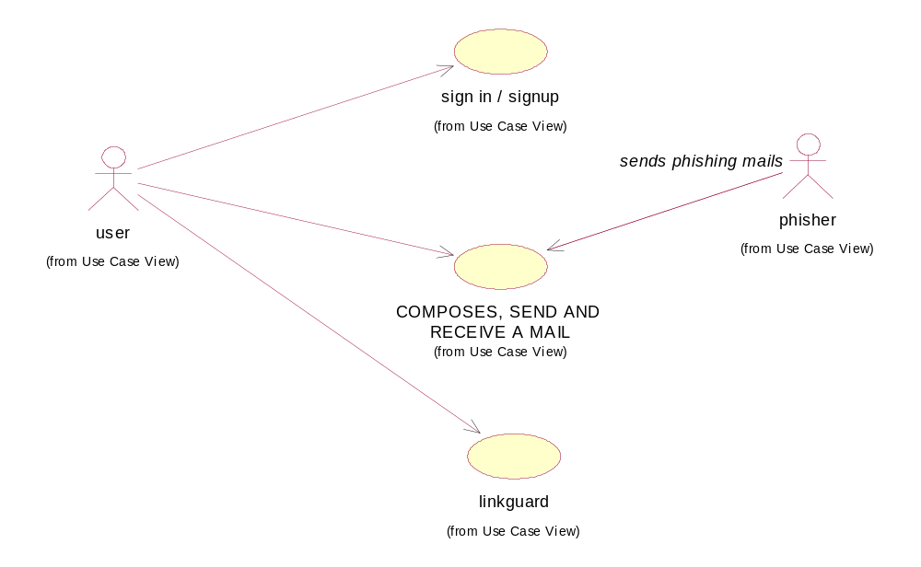

CLASS DIAGRAM:

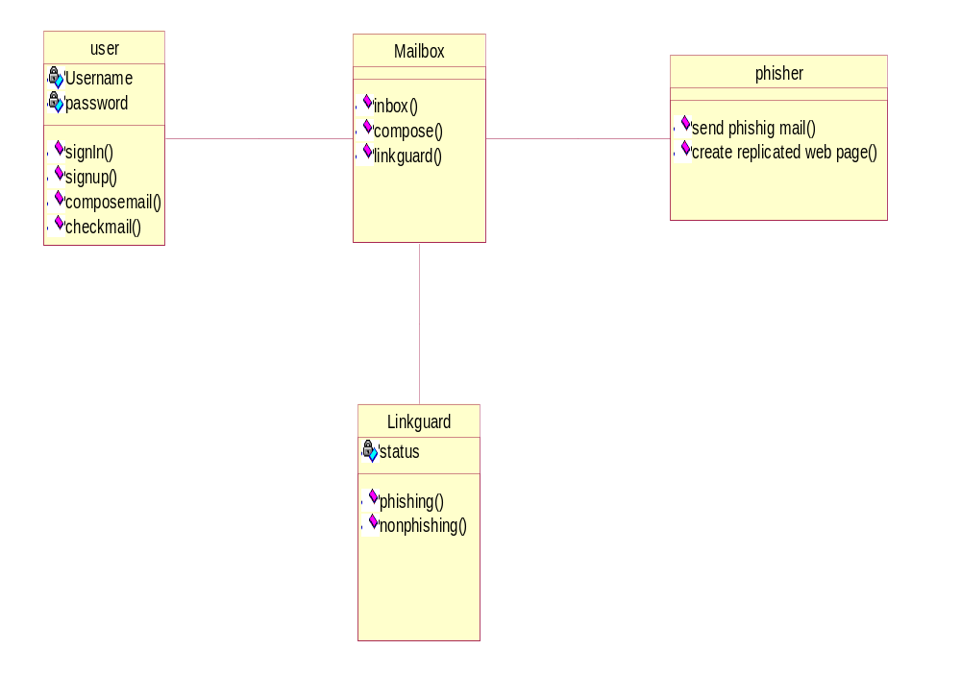

4.5 MODULE EXPLANATION:
Phishing can generally occur with Banking websites or e-shopping websites. This project explains the implementation of the Link Guard algorithm using a mail-box system.
There are three modules involved in this project:
  - Creation of a mail system and database operations
  - Composes, send and receive a mail
  - Implementation of the Link Guard algorithm
    - MODULE 1
This module deals with the user interface for the home page, sign-in, sign-up and forgot your password pages. This module enables a new user to Sing-Up. It also enables an existing user to Sign-In. The user may use the Forget password link if he did forget his password. The password is retrieved on the basis of security question and answer given by the user. Database operation manages the users. Every time a new user signs in his details are written in to the database.

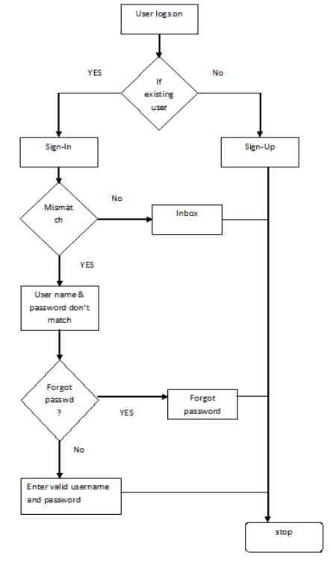
Fig.4.5.1 Creation of a mail system and database operations

4.5.2 MODULE 2
The module 2 enables the user to compose and send a mail. It also allows the user to read a received mail. Once a mail is sent the date and the subject of the mail gets displayed. The received mail can be checked if it is phishing or not, the implementation of which is given in the next module. The compose mail option contains an option for spoof id. The spoof id allows the mail of the composer to be delivered with a different from address. This is being incorporated to demonstrate the Link Guard algorithm.
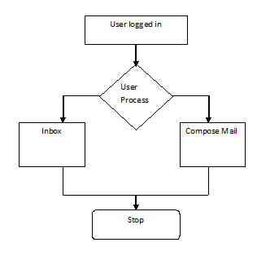
Fig 4.5.2 COMPOSES, SEND AND RECEIVE A MAIL

4.5.3 MODULE 3
The module contains the implementation of the Link Guard algorithm. It is possible for the user to add domain names and categorize them as either white list or black list under settings. Whenever a mail is detected as phishing the domain name in that mail automatically gets added as black list. The Link Guard algorithm checks if the domain names fall under any of the 5 categories of hyperlinks for phishing emails. It also refers to the database of black and white list entries and sets the status of the mail as either Phishing or Non-Phishing. Once the mail is categorized as Phishing the user can take care that he does not open the link or submit any personal, critical information on to the website.
Comm.:
This collects the information of the input process, and sends these related information’s to the Analyzer.
Database:
Store the white list, blacklist, and the user input URLs.
Analyzer:
It is the key component of Link Guard, which implements the Link guard algorithm; it uses data provided by Comm. and Database, and sends the results to the Alert and Logger modules.
Alerter:
When receiving a warning message from Analyzer, it shows the related information to alert the users and send back the reactions of the user back to the Analyzer.
Logger:
Archive the history information, such as user events, alert information, for future use.

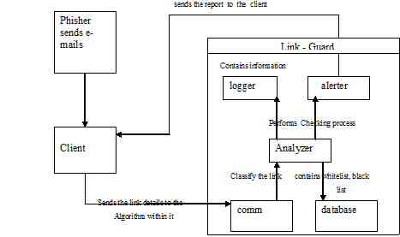

Fig 4.5.3 IMPLEMENTATION OF THE LINK GUARD ALGORITHM

4.6 IMPLEMENTATION OF LINK GUARD ALGORITHM
Link Guard works by analyzing the differences between the visual link and the actual link. It also calculates the similarities of a URI with a known trusted site. The algorithm is illustrated in Fig.1 The following terminologies are used in the algorithm.
v_link: visual link;
a_link: actual_link;
v_dns: visual DNS name;
a_dns: actual DNS name;
sender_dns: sender’s DNS name.
1 .int Link Guard (v_link, a_link} {
2. v_dns = GetDNSName(v_link);
3. a_dns = GetDNSName(a_link);
4. if ((v_dns and a_dns are not
5. empty) and (v_dns != a_dns))
6. Return PHISHING;
7. if (a_dns is dotted decimal)
8. return POSSIBLE_PHISHING;
9. if (a_link or v_link is encoded)
10.{
11. v_link2 = decode (v_link);
12. A_link2 = decode (a_link);
13. return Link Guard(v_link2, a_link2);
14. }
15. /*analyze the domain name for possible phishing*/
16. if (v_dns is NULL)
17. return AnalyzeDNS(a_link);
18. }
Fig. 1. Description of the Link Guard algorithm.
The Link Guard algorithm works as follows. In its main routine Link Guard, it first extracts the DNS names from the actual and the visual links (lines 1 and 2). It then compares
the actual and visual DNS names, if these names are not the same, then it is phishing of category 1 (lines 3-5). If dotted decimal IP address is directly used in actual dns, it is then
a possible phishing attack of category 2 (lines 6 and 7). We will delay the discussion of how to handle possible phishing attacks later. If the actual link or the visual link is encoded

19. int AnalyzeDNS (actual link) {
/return PHISHING;
*Analyze the actual DNS name according
to the blacklist and whitelist
*/
20. if (actual_dns in blacklist)
21. if (actual_dns in whitelist)
22. Return NOTPHISHING;
23. return Pattern Matching(actual_link);
}
24. int Pattern Matching(actual_link){
25. if (sender_dns and actual_dns are different)
26. return POSSIBLE_PHISHING;
27. for (each item prev_dns in seed_set)
28. {
29. bv = Similarity(prev_dns, actual_link);
30. if (bv == true)
31. return POSSIBLE_PHISHING;
32. }
33. return NO_PHISHING;
}
34. float Similarity (str, actual_link) {
35. if (str is part of actual_link)
36. Return true;
37 int maxlen = the maximum string
38. Lengths of str and actual_dns;
39 int minchange = the minimum number of
40. Changes needed to transform str
41. To actual_dns (or vice verse);
42. if (thresh<(maxlen-minchange)/maxlen<1)
43. return true/
44. return false;
45}
Fig. 2. The subroutines used in the Link Guard algorithm. (Categories 3 and 4), we first decode the links, then recursively call Link Guard to return a result (lines 8-13). When there is no destination information (DNS name or dotted IP address) in the visual link (category 5), Link Guard calls AnalyzeDNS to analyze the actual dns (lines 16 and 17). Link Guard therefore handles all the 5 categories of phishing attacks. AnalyzeDNS and the related subroutines are depicted in Fig.
2. In AnalyzeDNS, if the actual dns name is contained in the blacklist, then we are sure that it is a phishing attack (lines18 and 19). Similarly, if the actual dns is contained in the
White list, it is therefore not a phishing attack (lines 20 and21). If the actual dns is not contained in either white list or blacklist, Pattern Matching is then invoked (line 22).
Pattern Matching is designed to handle unknown attacks (blacklist/whitelist is useless in this case). For category 5 of the phishing attacks, all the information we have is the actual link
From the hyperlink (since the visual link does not contain DNS or IP address of the destination site), which provide very little information for further analysis. In order to resolve this problem, we try two methods: First, we extract the sender e-mail address from the e-mail. Since phishers generally try to fool users by using (spoofed) legal DNS names in the sender e-mail address, we expect that the DNS name in the sender address will be different from that in the actual link. Second, we proactively collect DNS names that are manually input by the user when she surfs the Internet and store the names into a seed set, and since these names are input by the user by hand, we assume that these names are trustworthy. Pattern Matching then checks if the actual DNS name of a hyperlink is different
from the DNS name in the sender’s address (lines 23 and 24), and if it is quite similar (but not identical) with one or more names in the seed set by invoking the Similarity (lines 25-30)
Procedure. Similarity checks the maximum likelihood of actual dns and the DNS names in seed set. As depicted in Fig. 2, the similarity index between two strings are determined by calculating the minimal number of changes (including insertion, deletion, or revision of a character in the string) needed to transform a string to the other string. If the number of changes is 0, then the two strings are identical; if the number of changes is small, then they are of high similarity; otherwise, they are of low similarity. For example, the similarity index of ‘microsoft’ and ‘micr0s0ft’ is 7/9 (since we need change the 2 ‘0’s in micr0s0ft to ‘o’. Similarly, the similarity index of ‘paypal’ and ‘paypal-cgi’ is 6/10 (since we need to remove the last 4 chars from paypal-cgi), and the similarity index of ‘95559’ and ‘955559’ is 5/6 (since we need to insert a ‘5’ to change ‘95559’ to ‘955559’). If the two DNS names are similar but not identical, then it is a possible phishing attack. For instance, Pattern Matching can easily detect the difference between www.icbc.com.cn (which is a good e-commence Web site) and www.1cbc.com.cn (which is a phishing site), which has similarity index 75%.
Note that Pattern Matching may treat www.1cbc.com.cn as a normal site if the user had never visit www.1cbc.com.cn before. This false negative, however, is unlikely to cause
any severe privacy or financial lose to the user, since she actually does not have anything to lose regarding the Web site www.icbc.com.cn (since she never visits that Web site before)!
C. False positives and false negatives handling
Since Link Guard is a rule-based heuristic algorithm, it may cause false positives (i.e., treat non-phishing site as phishing site) and false negatives (i.e., treat phishing site as non-
phishing site). In what follows, we show that Link Guard may result in false positives but is very unlikely to cause harmful false negatives.For phishing attacks of category 1, we are sure that there is no false positives or false negatives, since the DNS names of the visual and actual links are not the same. It is also easy to observe that Link Guard handles categories 3 and 4 correctly since the encoded links are first decoded before further analysis.
For category 2, Link Guard may result in false positives, since using dotted decimal IP addresses instead of domain names may be desirable in some special circumstances (e.g.,
when the DNS names are still not registered). For category 5, Link Guard may also result in false positives. For example, we know that both ‘www.iee.org’ and ‘www.ieee.org’ are
legal Web sites. But these two DNS names have a similarity index of 3/4, hence is very likely to trigger a false positive. When it is a possible false positive, Link Guard will return a
POSSIBLE PHISHING. In our implementation (which will be described in the next section), we leverage the user to judge if it is a phishing attack by prompting a dialogue box with
Detailed information of the hyperlink. The rationale behind this choice is that users generally may have more knowledge of a link than a computer in certain circumstances (e.g., the user
may know that the dotted decimal IP address is the address of his friend’s computer and that www.iee.org is a respected site for electrical engineers). For category 5, Link Guard may also result in false negatives. False negatives are more harmful than false positives, since attackers in this case will succeed in leading the victim to the phishing sites. For instance, when the sender’s e-mail address and the DNS name in the actual link are the same and the DNS name in the actual link has a very low similarity index with the target site, LinkGuard will return NO PHISHING. For instance, PatternMatching will treat the below link as NO PHISHING.
<a href="http://fdic-secure.com/
application.htm"> Click here </a>
with “securehq@fdic-secure.com” as the sender address. We note that this kind of false negatives is very unlikely to result in information leakage, since the end user is very
unlikely to have information the attack interested (since the DNS name in this link is not similar with any legal Web sites).

4.7 SYSTEM DESIGN
4.7.1. Database File Structure

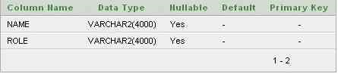

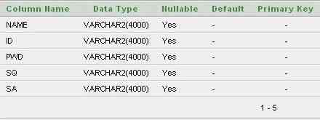

IMPLEMENTATION

5. IMPLEMENTATION
5.1 SIGN IN:
import java.io.*;
import java.sql.Connection;
import java.sql.DriverManager;
import java.sql.PreparedStatement;
import java.sql.ResultSet;
import java.sql.Statement;
import javax.servlet.*;
import javax.servlet.http.*;
import Appn.Member;
import oracle.jdbc.pool.OracleDataSource;
public class Signin extends HttpServlet
{
public void doPost(HttpServletRequest request,HttpServletResponse response)
throws ServletException, IOException
{
PrintWriter out = response.getWriter();
Member member=new Member();
member.id=request.getParameter("p1")+"@global.com";
member.pwd=request.getParameter("p2");
boolean result=signin(member);
if(result)
{
HttpSession ses=request.getSession(true);
if(ses!=null)
{
ses.setAttribute("user",member.id);
ses.setAttribute("pwd",member.pwd);
}
RequestDispatcher rq=request.getRequestDispatcher("inbox.jsp");
rq.forward(request,response);
}
else
{
RequestDispatcher rq=request.getRequestDispatcher("home.jsp");
request.setAttribute("msg","In valid entries");
rq.forward(request,response);
}
}
public boolean signin(Member member)
{
boolean exist=false;
try
{
DriverManager.registerDriver( new oracle.jdbc.driver.OracleDriver());
Connection conn = DriverManager.getConnection( "jdbc:oracle:thin:@"+getServletConfig().getServletContext().getInitParameter("server"),"system","redhat" );
//PreparedStatement st = conn.prepareStatement("select * from MEMBER where id = '"+member.id+"'"+"and pwd= '"+member.pwd+"'");
Statement st = conn.createStatement();
ResultSet rs = st.executeQuery("select * from MEMBER where id ='"+member.id+"' and pwd='"+member.pwd+"'");
System.out.println(member.id+"ggg:"+member.pwd);
while(rs.next())
{
exist=true;
System.out.println("step1");
}
st.close();
conn.close();
}
catch(Exception e)
{
e.printStackTrace();
return false;
}
return exist;
}
}
5.2 SIGN UP:
import java.io.*;
import java.sql.Connection;
import java.sql.DriverManager;
import java.sql.PreparedStatement;
import java.sql.ResultSet;
import java.sql.Statement;
import javax.servlet.*;
import javax.servlet.http.*;
import Appn.Member;
import oracle.jdbc.pool.OracleDataSource;
public class Signin extends HttpServlet
{
public void doPost(HttpServletRequest request,HttpServletResponse response)
throws ServletException, IOException
{
PrintWriter out = response.getWriter();
Member member=new Member();
member.id=request.getParameter("p1")+"@global.com";
member.pwd=request.getParameter("p2");
boolean result=signin(member);

if(result)
{
HttpSession ses=request.getSession(true);
if(ses!=null)
{
ses.setAttribute("user",member.id);
ses.setAttribute("pwd",member.pwd);
}
RequestDispatcher rq=request.getRequestDispatcher("inbox.jsp");
rq.forward(request,response);
}
else
{
RequestDispatcher rq=request.getRequestDispatcher("home.jsp");
request.setAttribute("msg","In valid entries");
rq.forward(request,response);
}
}
public boolean signin(Member member)
{
boolean exist=false;
try
{
DriverManager.registerDriver( new oracle.jdbc.driver.OracleDriver());
Connection conn = DriverManager.getConnection( "jdbc:oracle:thin:@"+getServletConfig().getServletContext().getInitParameter("server"),"system","redhat" );
//PreparedStatement st = conn.prepareStatement("select * from MEMBER where id = '"+member.id+"'"+"and pwd= '"+member.pwd+"'");
Statement st = conn.createStatement();
ResultSet rs = st.executeQuery("select * from MEMBER where id ='"+member.id+"' and pwd='"+member.pwd+"'");
System.out.println(member.id+"ggg:"+member.pwd);
while(rs.next())
{
exist=true;
System.out.println("step1");
}
st.close();
conn.close();
}
catch(Exception e)
{
e.printStackTrace();
return false;
}
return exist;
}
}
5.3 SEND MAIL:
import java.io.*;
import java.sql.Connection;
import java.sql.DriverManager;
import java.sql.PreparedStatement;
import java.sql.ResultSet;
import javax.servlet.*;
import javax.servlet.http.*;
import Appn.*;
public class Sendmail extends HttpServlet
{
public void doPost(HttpServletRequest request,HttpServletResponse response)
throws ServletException, IOException
{
PrintWriter out = response.getWriter();
String to=request.getParameter("t1").trim();
String sub=request.getParameter("t2");
String body=request.getParameter("t3");
String spoof="";
boolean result=check(to);
if(result)
{
Mail m=new Mail();
HttpSession ses=request.getSession();
boolean ack=m.send(getServletConfig().getServletContext().getInitParameter("server"),to,(String)ses.getAttribute("user"),sub,body,spoof);
if(ack)
{
RequestDispatcher rq=request.getRequestDispatcher("compose.jsp");
request.setAttribute("msg","Your Message Sent");
rq.forward(request,response);
}
else
{
RequestDispatcher rq=request.getRequestDispatcher("compose.jsp");
request.setAttribute("msg","The Message Sending failure");
rq.forward(request,response);
}
}
else
{
RequestDispatcher rq=request.getRequestDispatcher("compose.jsp");
request.setAttribute("msg","The receipient not exist");
rq.forward(request,response);
}
}
public boolean check(String to)
{
boolean exist=false;
try
{
DriverManager.registerDriver( new oracle.jdbc.driver.OracleDriver() );
Connection con=DriverManager.getConnection( "jdbc:oracle:thin:@"+getServletConfig().getServletContext().getInitParameter("server"),"system","redhat" );
PreparedStatement st = conn.prepareStatement("Select * from MEMBER WHERE id = '"+to+"'");
ResultSet rs = st.executeQuery();
while(rs.next())
{
exist=true;
}
st.close();
conn.close();
}
catch(Exception e)
{
e.printStackTrace();
return false;
}
return exist;
}
}
5.4 SERVER REG:
import java.io.File;
import java.io.FileOutputStream;
public class ServerReg
{
public void Reg(String s1,String s2,String path,String servername)
{
try
{
/* File f=new File(path+"/MAIL/"+user);
System.out.println(f.mkdirs());
System.out.println(f.getAbsolutePath());
File f1=new File(f.getAbsolutePath()+"/PASSWD.PM");
String str="# Mercury/32 User Information File"+"\n"+"POP3_access:"+pass+"\n"+"APOP_secret:";
FileOutputStream fi=new FileOutputStream(f1,false);
byte b[]=str.getBytes();
fi.write(b);
//FileWriter fw=new File Writer(f1);
//fw.append("# Mercury/32 User Information File"+"\n"+"POP3_access: ramkumar"+"\n"+"APOP_secret:");
File f2=new File(path+"/MAIL/PMAIL.USR");
FileOutputStream fii=new FileOutputStream (f2,true);
String s="U;"+user+";"+user+"\n";
byte b1[]=s.getBytes();
fii.write(b1);*/
File f=new File(path+"user.conf");
FileOutputStream fo=new FileOutputStream(f,true);
String str="\n"+"user."+s1+"@"+servername+"="+s2;
str=str+"\n";
str=str+"userprop."+s1+"@"+servername+".forwardAddresses=";
byte b[]=str.getBytes();
fo.write(b);
}
catch(Exception e)
{
e.printStackTrace ();
}
}
}
5.5 FORGET:
import java.io.*;
import java.sql.Connection;
import java.sql.DriverManager;
import java.sql.ResultSet;
import java.sql.Statement;
import javax.servlet.*;
import javax.servlet.http.*;
import Appn.Member;
import oracle.jdbc.pool.OracleDataSource;
public class Forget extends HttpServlet
{
String password;
public void doPost(HttpServletRequest request,HttpServletResponse response)
throws ServletException, IOException
{
PrintWriter out = response.getWriter();
Member member=new Member();
member.id=request.getParameter("p1");
member.secq=request.getParameter("p2");
member.seca=request.getParameter("p3");
boolean result=search(member);
if(result)
{
RequestDispatcher rq=request.getRequestDispatcher("forget.jsp");
request.setAttribute("msg","U r member.Ur Password is "+password);
rq.include(request,response);
}
else
{
RequestDispatcher rq=request.getRequestDispatcher("forget.jsp");
request.setAttribute("msg","Invalid Entry,Try again");
rq.include(request,response);
}
}
public boolean search(Member member)
{
boolean exist=false;
try
{
DriverManager.registerDriver( new oracle.jdbc.driver.OracleDriver() );
Connection con = DriverManager.getConnection( "jdbc:oracle:thin:@"+getServletConfig().getServletContext().getInitParameter("server"),"system","redhat" );
Statement st=con.createStatement();
ResultSet rs=st.executeQuery("Select * from MEMBER");
while(rs.next())
{
if(member.id.equals(rs.getString(2))&&member.secq.equals(rs.getString(4))&&member.seca.equals(rs.getString(5)))
{
password=rs.getString(3);
exist=true;
break;
}
}
st.close();
con.close();
}
catch(Exception e)
{
return false;
}
return exist;
}
}
5.6 DOMAIN:
import java.io.*;
import java.sql.Connection;
import java.sql.DriverManager;
import java.sql.PreparedStatement;
import java.sql.ResultSet;
import javax.servlet.*;
import javax.servlet.http.*;

public class Domain extends HttpServlet
{
Exception e1=null;
public void doPost(HttpServletRequest request,HttpServletResponse response)
throws ServletException, IOException
{
PrintWriter out = response.getWriter();
String name=request.getParameter("t1");
String type=request.getParameter("t2");
boolean result=check(name);
if(result)
{
RequestDispatcher rq=request.getRequestDispatcher("settings.jsp");
request.setAttribute("msg","The Domain name already exist");
rq.forward(request,response);
}
else
{
if(save(name,type))
{
RequestDispatcher rq=request.getRequestDispatcher("settings.jsp");
request.setAttribute("msg","The Domain name successfully saved");
rq.forward(request,response);
}
else
{
RequestDispatcher rq=request.getRequestDispatcher("settings.jsp");
request.setAttribute("msg",e1);
rq.forward(request,response);
}
}
}
public boolean check(String name)
{
boolean exist=false;
try
{
DriverManager.registerDriver( new oracle.jdbc.driver.OracleDriver() );
Connection conn = DriverManager.getConnection( "jdbc:oracle:thin:@"+getServletConfig().getServletContext().getInitParameter("server"),"system","redhat" );
PreparedStatement st = conn.prepareStatement("Select * from LIST WHERE name= '"+name+"'");
ResultSet rs = st.executeQuery();
while(rs.next())
{
exist=true;
}

st.close();
conn.close();
}
catch(Exception e)
{
e.printStackTrace();
return false;
}

return exist;
}
public boolean save(String name,String type)
{
try
{
DriverManager.registerDriver( new oracle.jdbc.driver.OracleDriver() );
Connection conn = DriverManager.getConnection ("jdbc:oracle:thin:@"+getServletConfig().getServletContext().getInitParameter("server"),"system","redhat" );
PreparedStatement st = conn.prepareStatement("Select * from LIST");
String query="insert into LIST values('"+name+"','"+type+"')";
st.executeUpdate(query);
st.close();
conn.close();
return true;
}
catch(Exception e)
{
e1=e;
return false;
}
}
}
5.7 HOME:
import java.io.*;
import javax.servlet.*;
import javax.servlet.http.*;
public class Home extends HttpServlet
{
String password;
public void doGet(HttpServletRequest request,HttpServletResponse response)
throws ServletException, IOException
{
PrintWriter out = response.getWriter();
RequestDispatcher rq=request.getRequestDispatcher("home.html");
rq.include(request,response);
}
}

TESTING

6. TESTING
Testing is a process, which reveals errors in the program. It is the major quality measure employed during software development. During testing, the program is executed with a set of conditions known as test cases and the output is evaluated to determine whether the program is performing as expected.
Software testing is the process of testing the functionality and correctness of software by running it. Process of executing a program with the intent of finding an error.
A good test case is one that has a high probability of finding an as yet undiscovered error. A successful test is one that uncovers an as yet undiscovered error. Software testing is usually performed for two reasons.
- Defect detection
- Reliability estimation
6.1 TESTING OBJECTIVES
- Testing is a process of executing a program with the intent of finding an error.
- A good test case is one that has a high probability of finding an as yet undiscovered.
- A successful test is one that uncovers an as yet undiscovered error.
6.2 TESTING PRINCIPLES:
- All tests should be traceable to customer requirements.
- Tests should be planned large before testing begins.
- Testing should begin “In the Small” and progress towards “In the Large”.
6.3 TYPES OF TESTING:
In order to make sure that the system does not have errors, the different levels of testing strategies that are applied at differing phases of software development are:

Unit Testing:
Unit Testing is done on individual modules as they are completed and become executable. It is confined only to the designer's requirements.
Each module can be tested using the following two strategies:
i) Black Box Testing:
In this strategy some test cases are generated as input conditions that fully execute all functional requirements for the program. This testing has been uses to find errors in the following categories:
- Incorrect or missing functions
- Interface errors
- Errors in data structure or external database access
- Performance errors
- Initialization and termination errors.
In this testing only the output is checked for correctness. The logical flow of the data is not checked.
ii) White Box testing:
In this the test cases are generated on the logic of each module by drawing flow graphs of that module and logical decisions are tested on all the cases.
It has been uses to generate the test cases in the following cases:
- Guarantee that all independent paths have been executed.
- Execute all logical decisions on their true and false sides.
- Execute all loops at their boundaries and within their operational bounds.
- Execute internal data structures to ensure their valid
2. Integrating Testing:
Integration testing ensures that software and subsystems work together as a whole. It tests the interface of all the modules to make sure that the modules behave properly when integrated together.
3. System Testing:
Involves in-house testing of the entire system before delivery to the user. Its aim is to satisfy the user the system meets all requirements of the client's specifications.

4. Acceptance Testing:
It is a pre-delivery testing in which entire system is tested at client's site on real world data to
find errors.
Validation:
The system has been tested and implemented successfully and thus ensured that all the requirements as listed in the software requirements specification are completely fulfilled. In case of erroneous input corresponding error messages are displayed.

COMPILING TEST
It was a good idea to do our stress testing early on, because it gave us time to fix some of the unexpected deadlocks and stability problems that only occurred when components were exposed to very high transaction volumes.
EXECUTION TEST
This program was successfully loaded and executed. Because of good programming there were no execution errors.

OUTPUT TEST
The successful output screens are placed in the output screens section above.

6.4 TEST CASES:
Test case 1:Login |  | Priority (H, L): High
Test Objective: To check whether the user/administrator is valid or not.
Test Description: when a user or administrator clicks the link, a login form will be displayed. In this form if user wants to register he has to click on “Register Now” link otherwise if he is registered user then he can enter the “User ID” and “Password” and click the submit button to login.

Requirements Verified: Yes
Test Environment: Apache Tomcat Server.
Test Setup/Pre-Conditions: Server should be in on state

Actions | Expected Results
The user/administrator will login through the login form | Schemes form, movie schedule form administrator form
Pass: Yes Conditions pass: No Fail: No
Problems / Issues: NIL
Notes: Successfully Executed

Test case 2:Login without UserID |  | Priority (H, L): High
Test Objective: To check whether the user/administrator can login without his userid.
Test Description: when a user or administrator clicks the link, a login form will be displayed. In this form if user wants to login he has to enter userid and password. If he doesn’t enter and then tries to login, he will get a message indicating “user id is mandatory”.

Requirements Verified: Yes
Test Environment: Apache Tomcat Server.
Test Setup/Pre-Conditions: Server should be in on state

Actions | Expected Results
The user/administrator will login through the login form | A relevant message should appear.
Pass: Yes Conditions pass: No Fail: No
Problems / Issues: NIL
Notes: Successfully Executed

Test case 3: Change Password |  | Priority (H, L): High
Test Objective: To check whether the user can change his password when desired.
Test Description: when a user or administrator clicks the link to change the password, then a window appears to reset password. In that a new password is given and then updated.

Requirements Verified: Yes
Test Environment: Apache Tomcat Server.
Test Setup/Pre-Conditions: Server should be in on state

Actions | Expected Results
The user/administrator will login through the login form | When user logins with new password then he should be allowed to login.
Pass: Yes Conditions pass: No Fail: No
Problems / Issues: NIL
Notes: Successfully Executed

Test case 4: Conformance of new password. |  | Priority (H, L): High
Test Objective: To check whether the new password is updated or not.
Test Description: when a user or administrator changes the password, then we check for conformance of the password.

Requirements Verified: Yes
Test Environment: Apache Tomcat Server.
Test Setup/Pre-Conditions: Server should be in on state

Actions | Expected Results
The user/administrator will login through the login form | Message should appear if the password was updated.
Pass: Yes Conditions pass: No Fail: No
Problems / Issues: NIL
Notes: Successfully Executed

Test case 5: Receive Mail. |  | Priority (H, L): High
Test Objective: To check whether the mail is received or not.
Test Description: To check whether the mail has been read or not and if the mail has not been read then alert is reflected on the screen.

Requirements Verified: Yes
Test Environment: Apache Tomcat Server.
Test Setup/Pre-Conditions: Server should be in on state

Actions | Expected Results
The user/administrator will login through the login form | If mail is received, message appears that mail is received.
Pass: Yes Conditions pass: No Fail: No
Problems / Issues: NIL
Notes: Successfully Executed

Test case 6: Sending Mail. |  | Priority (H, L): High
Test Objective: To check whether the mail is sending or not.
Test Description: To check whether the mail has been send or not and if the mail has not been send then alert is reflected on the screen.

Requirements Verified: Yes
Test Environment: Apache Tomcat Server.
Test Setup/Pre-Conditions: Server should be in on state

Actions | Expected Results
The user/administrator will login through the login form | If mail is sent, message appears that mail is sent.
Pass: Yes Conditions pass: No Fail: No
Problems / Issues: NIL
Notes: Successfully Executed

SCREENS

7.1 LOGIN PAGE:
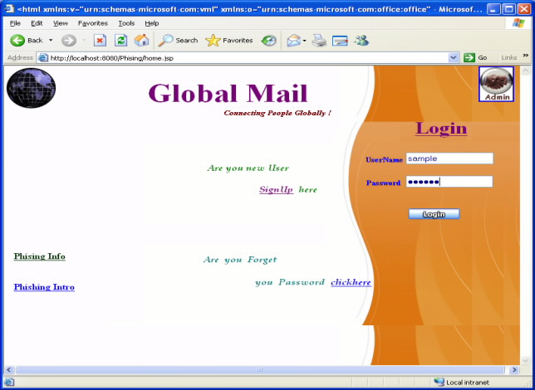

7.2 REGISTRATION FORM:
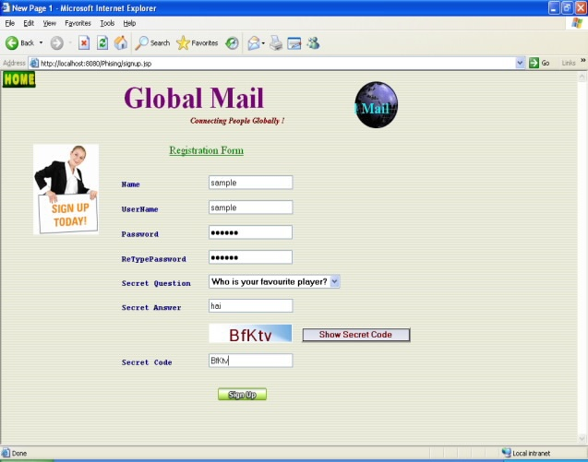

7.3 USER ID:
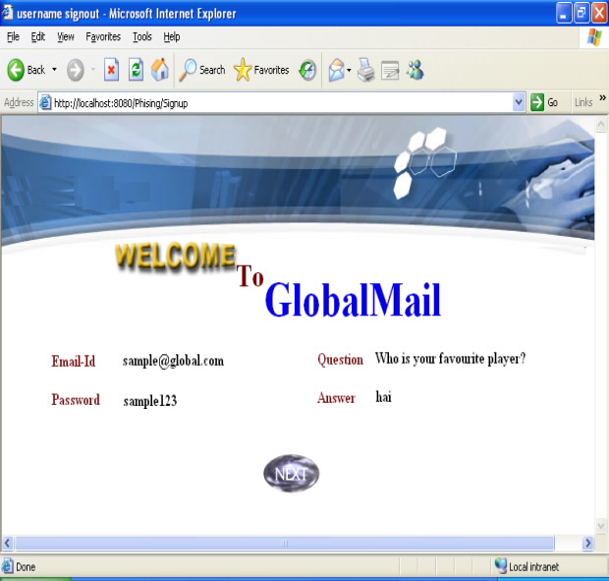

7.4 INBOX:
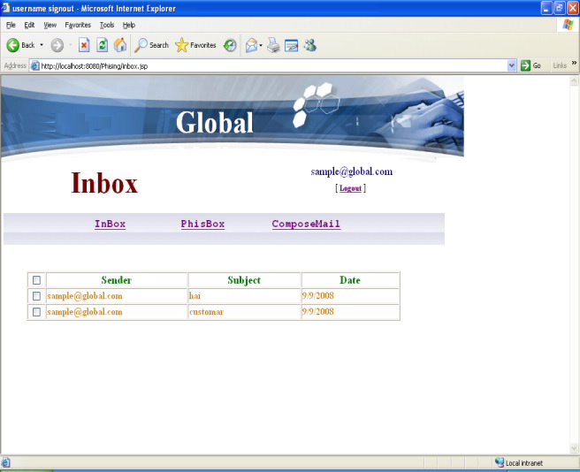

7.5 PHISBOX:
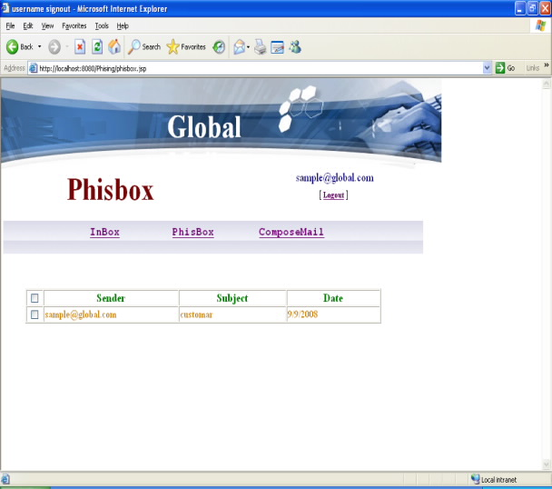

7.6 COMPOSE MAIL:
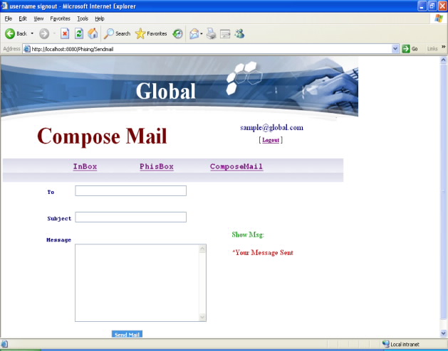

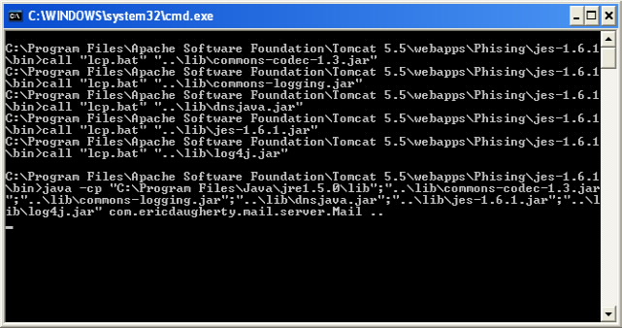

7.7 FORGET PASSWORD FORM:
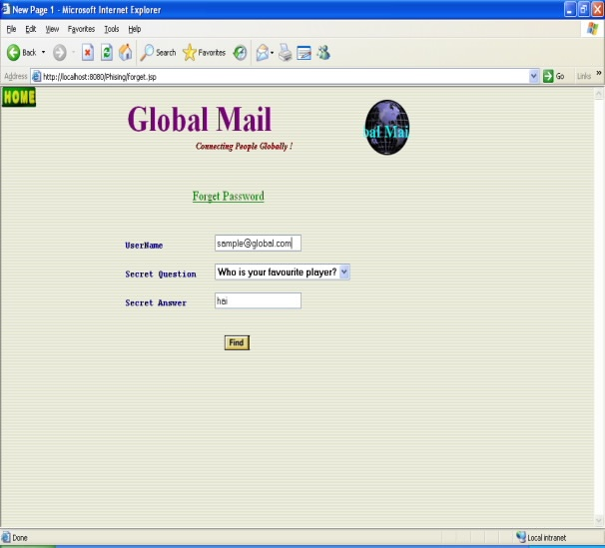

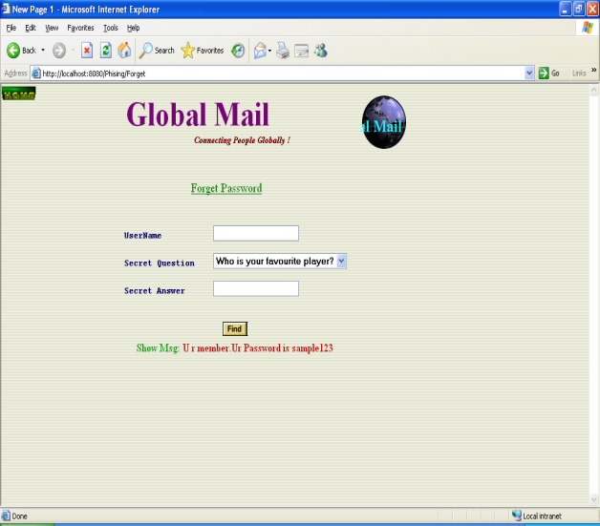

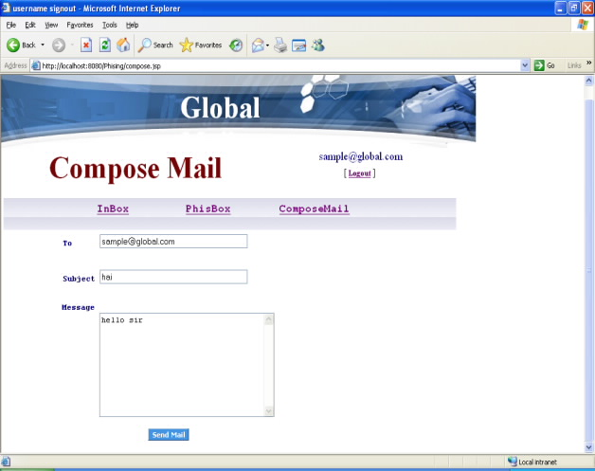

CONCLUSION

8. CONCLUSION
Phishing has becoming a serious network security problem, causing finical lose of billions of dollars to both consumers and e-commerce companies. And perhaps more fundamentally, phishing has made e-commerce distrusted and less attractive to normal consumers. In this paper, we have studied the characteristics of the hyperlinks that were embedded in phishing e-mails. We then designed an anti-phishing algorithm, Link Guard, based on the derived characteristics. Since Phishing Guard is characteristic based, it can not only detect known attacks, but also is effective to the unknown ones.
We have implemented Link Guard for Windows XP. Our experiment showed that Link Guard is light-weighted and can detect up to 96% unknown phishing attacks in real-time. We believe that Link Guard is not only useful for detecting phishing attacks, but also can shield users from malicious or unsolicited links in Web pages and Instant messages. Our future work includes further extending the Link Guard algorithm, so that it can handle CSS (cross site scripting) attacks.

FUTURE ENHANCEMENT

9. FUTURE ENHANCEMENT
Our future work includes further extending the Link Guard algorithm, so that it can handle Cross Site Scripting (CSS) attacks. Cross-site scripting (CSS) is a type of computer security vulnerability typically found in web applications which allow code injection by malicious web users into the web pages viewed by other users. Examples of such code include HTML code and client-side scripts. An exploited cross-site scripting vulnerability can be used by attackers to bypass access controls such as the same origin policy. Vulnerabilities of this kind have been exploited to craft powerful phishing attacks and browser exploits. Cross-site scripting was originally referred to as CSS, although this usage has been largely discontinued due to the
confusion with cascading style sheets.

BIBLIOGRAPHY

10. BIBLIOGRAPHY
- Androutsopoulos, J. Koutsias, K.V. Chandrinos, and C.D. Spyropoulos. An Experimental Comparison of Naive Bayesian and Keyword-Based Anti-Spam Filtering with Encrypted Personal E-mail Message.In Proc. SIGIR 2000, 2000.
- The Anti-phishing working group. http://www.antiphishing.org/.
- Neil Chou, Robert Ledesma, Yuka Teraguchi, Dan Boneh, and John C.Mitchell. Client-side defense against web-based identity theft. In Proc.NDSS 2004, 2004.
- Cynthia Dwork, Andrew Goldberg, and Moni Naor. On Memory-Bound Functions for Fighting Spam. In Proc. Crypto 2003, 2003.
- EarthLink. ScamBlocker. http://www.earthlink.net/software/free/toolbar/.
- David Geer. Security Technologies Go Phishing. IEEE Computer, 38(6):18–21, 2005.
- John Leyden.Trusted search software labels fraud site as ’safe’ http://www.theregister.co.uk/2005/09/27/untrusted search/.
- Microsoft.Sender ID Framework.http://www.microsoft.com/mscorp/safety/technologies/senderid/default.mspx.
- Netcraft. Net craft toolbar. http://toolbar.netcraft.com/.
- PhishGuard.com.Protect Against Internet Phishing Scams .http://www.phishguard.com/.
- Jonathan B. Postel. Simple Mail Transfer Protocol.RFC821:http://www.ietf.org/rfc/rfc0821.txt.
- Georgina Stanley. Internet Security-Gone phishing. http://www.cyota.com/news.asp?id=114.
- MengWengWong. Sender ID SPF. http://www.openspf.org/whitepaper.pdf. 7

